DATA COLLECTION BASED ON GOAL 17

Target 17.1: Mobilize resources to improve domestic revenue collection.

Government revenue - Indicator 17.1.1 is total government revenue as a proportion of GDP.Revenue is cash receipts from taxes, social contributions, and other revenues such as fines, fees, rent, and income from property or sales. Grants are also considered revenue but are excluded here.

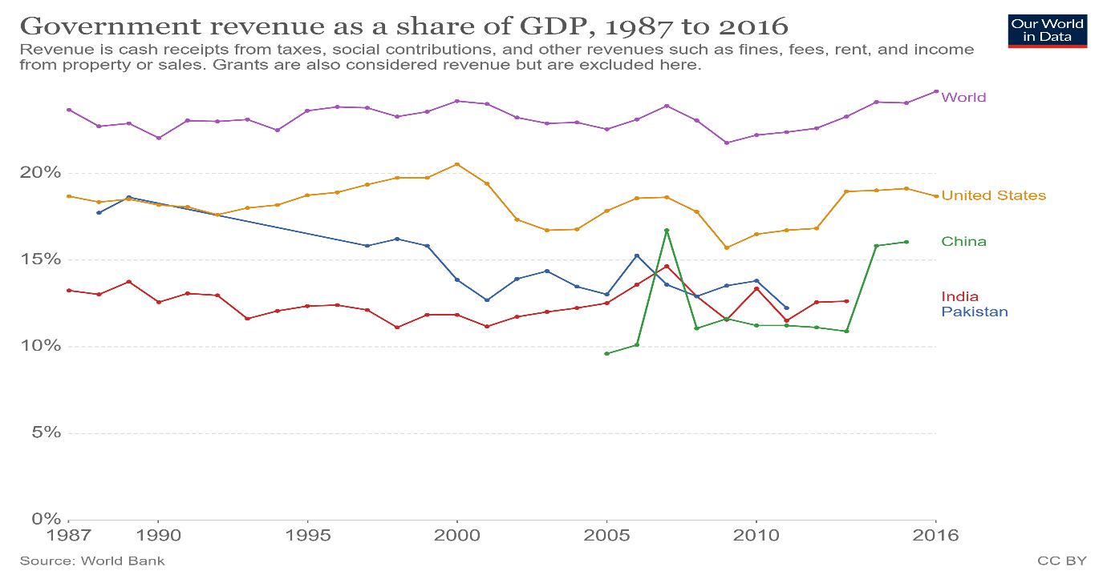

Domestic taxes - Indicator 17.1.2 is the proportion of domestic budget funded by domestic taxes. Tax revenue refers to compulsory transfers to the central government for public purposes. Compulsory transfers such as fines, penalties, and most social security contributions are excluded.

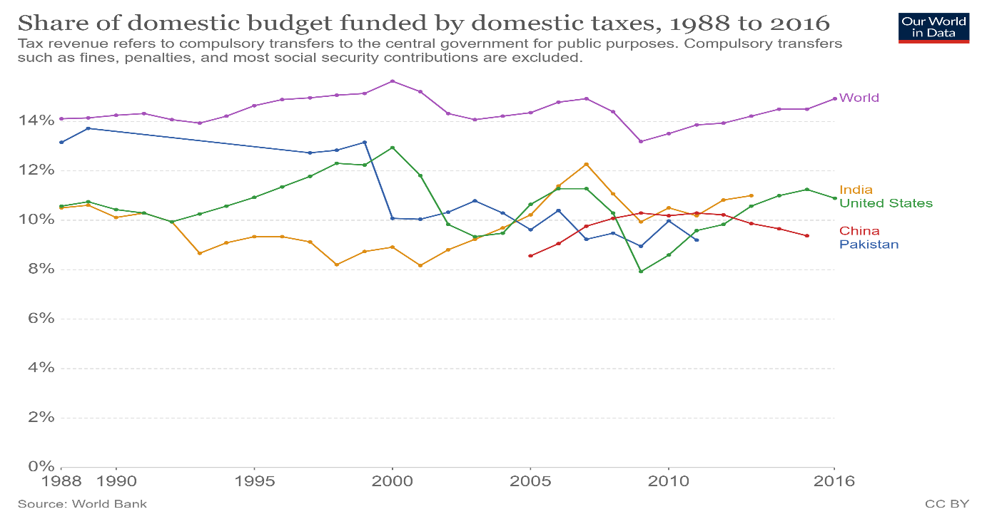

Target 17.2: Implement all development assistance commitments.

Development assistance to least-developed countries - Indicator 17.2.1 is net official development assistance, as a proportion of the Organization for Economic Cooperation and Development (OECD) Development Assistance Committee donors’ gross national income (GNI).

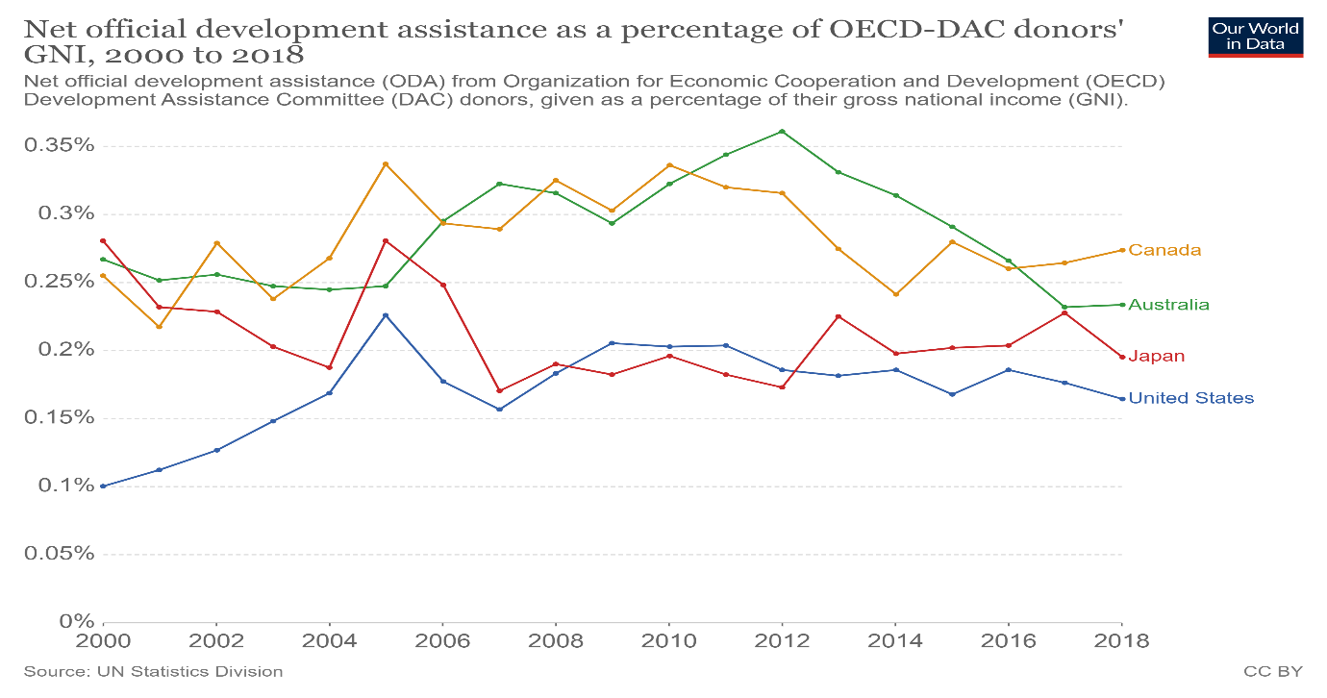

Target 17.3: Mobilize financial resources for developing countries.

Foreign direct investment - Indicator 17.3.1 is foreign direct investment (FDI), official development assistance and South-South cooperation as a proportion of total domestic budget.

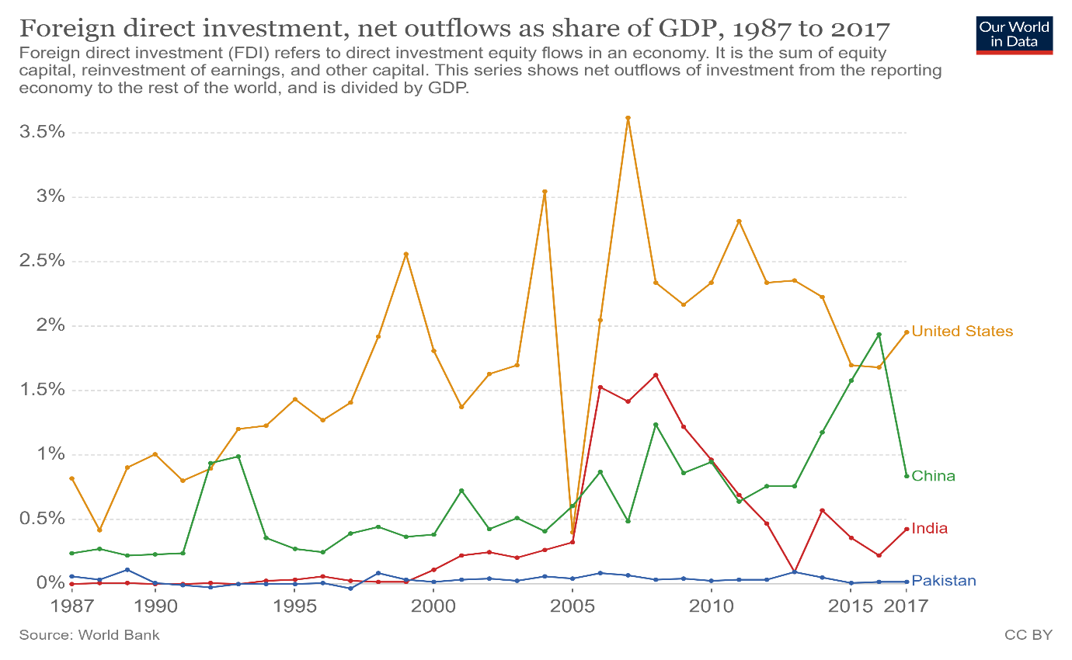

Volume of remittances - Indicator 17.3.2 is the volume of remittances (in United States dollars) as a proportion of total GDP.

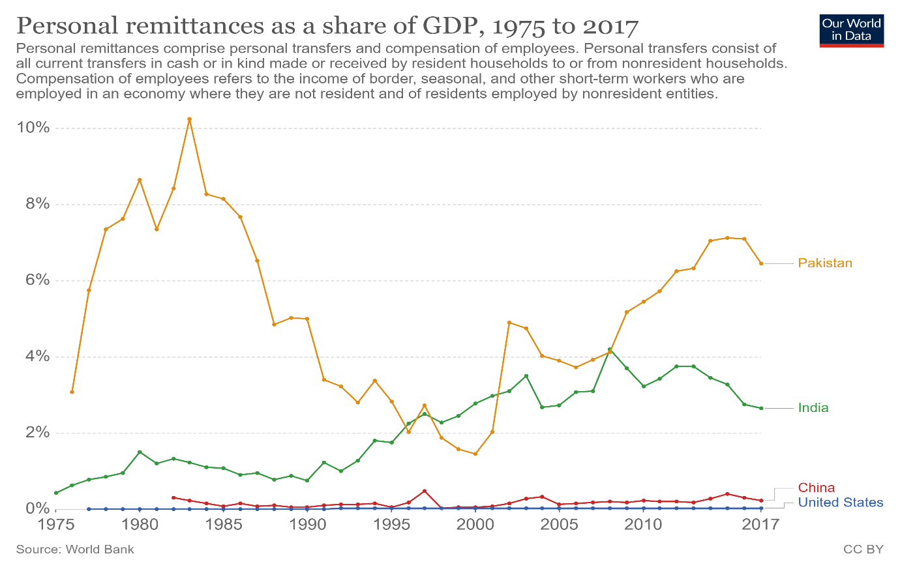

Target 17.4: Assist developing countries in attaining debt sustainability.

Debt service - Indicator 17.4.1 is debt service as a proportion of exports of goods and services.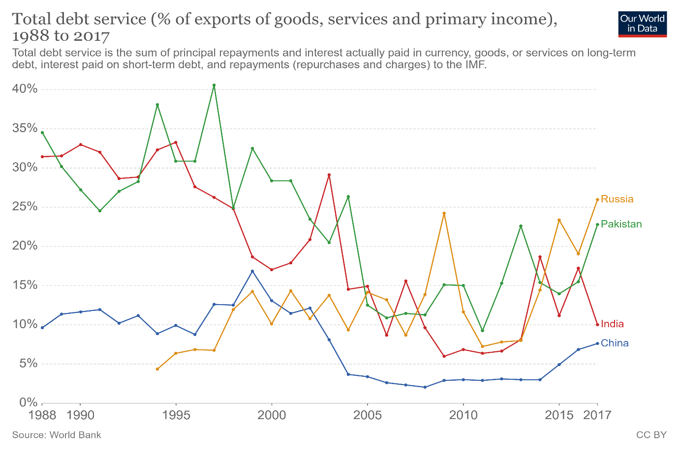

Target 17.5: Invest in least-developed countries.

Investment promotion for least-developed countries - Indicator 17.5.1 is the number of countries that adopt and implement investment promotion regimes for least developed countries.

Target 17.6: Knowledge sharing and cooperation for access to science, technology and innovation.

Science and technology cooperation - Indicator 17.6.1 is the number of science and/or technology cooperation agreements and programmes between countries.

Fixed broadband subscriptions - Indicator 17.6.2 is fixed Internet broadband subscriptions per 100 inhabitants.

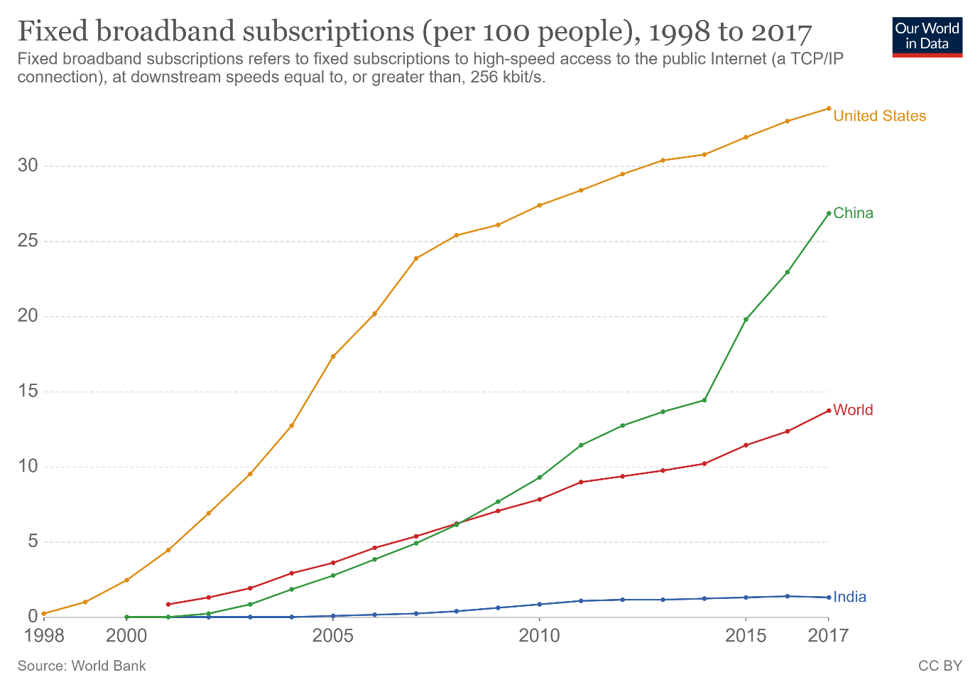

Target 17.7: Promote sustainable technologies to developing countries.

Sustainable technologies in developing countries - Indicator 17.7.1 is the total amount of approved funding for developing countries to promote the development, transfer, dissemination and diffusion of environmentally sound technologies.

Target 17.8: Strengthen the science, technology and innovation capacity for least-developed countries.

Individuals using the Internet - Indicator 17.8.1 is the proportion of individuals using the Internet.

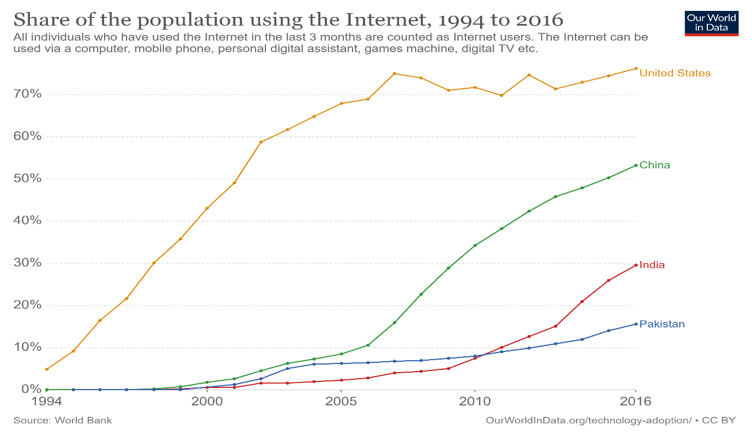

Target 17.9: Enhanced SDG capacity in developing countries.

SDG support for developing countries - Indicator 17.9.1 is the dollar value of financial and technical assistance committed to developing countries.

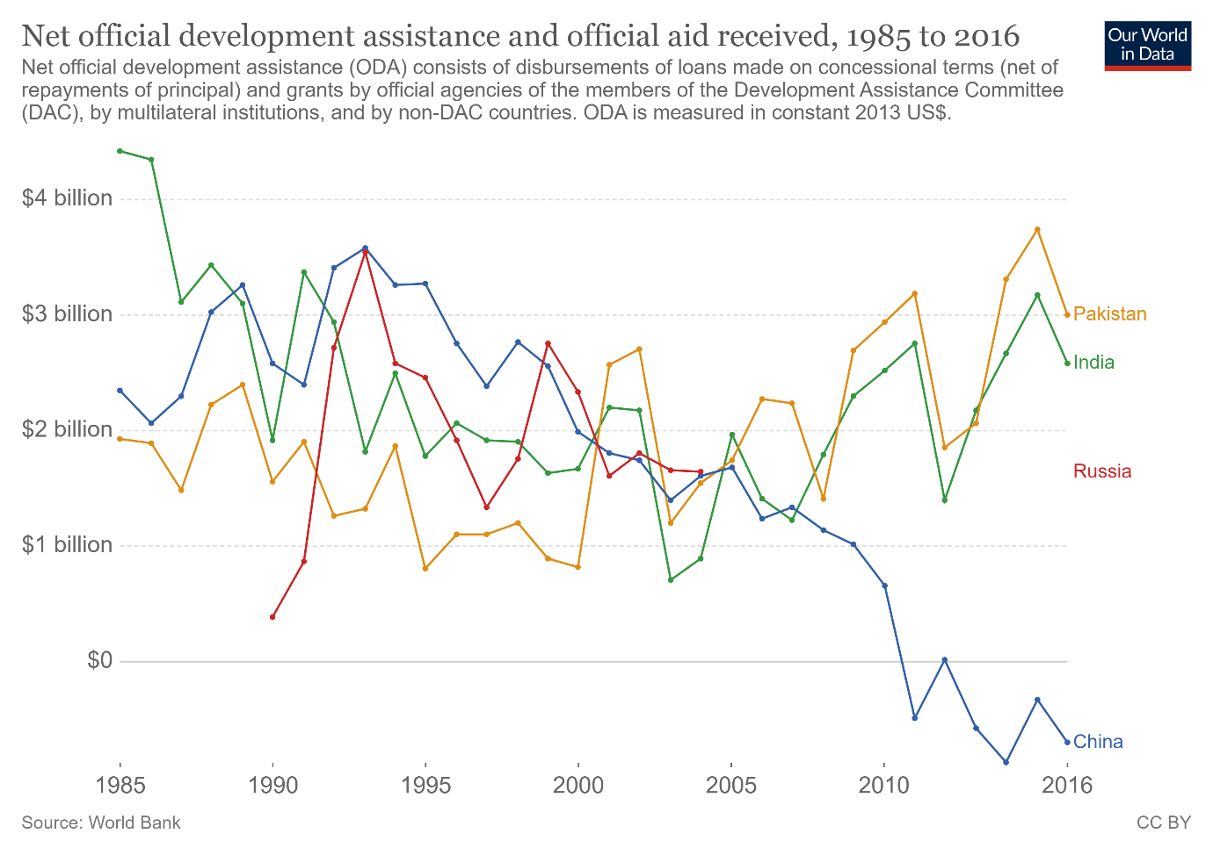

Target 17.10: Promote a universal trading system under the WTO.

Weighted average tariffs - Indicator 17.10.1 is the worldwide weighted tariff-average.

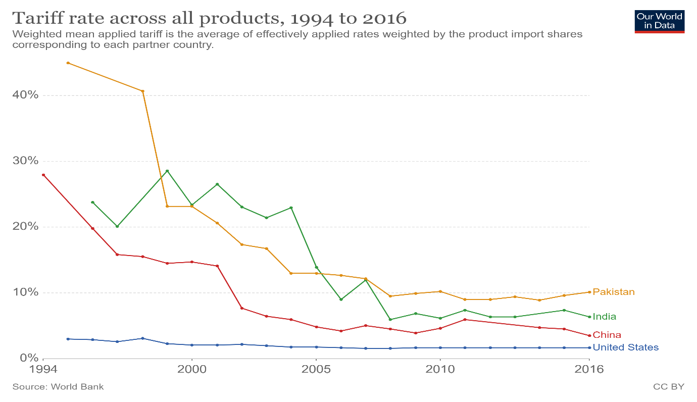

Target 17.11: Increase the exports of developing countries.

Exports from developing countries - Indicator 17.11.1 is developing countries’ and least developed countries’ share of global exports.

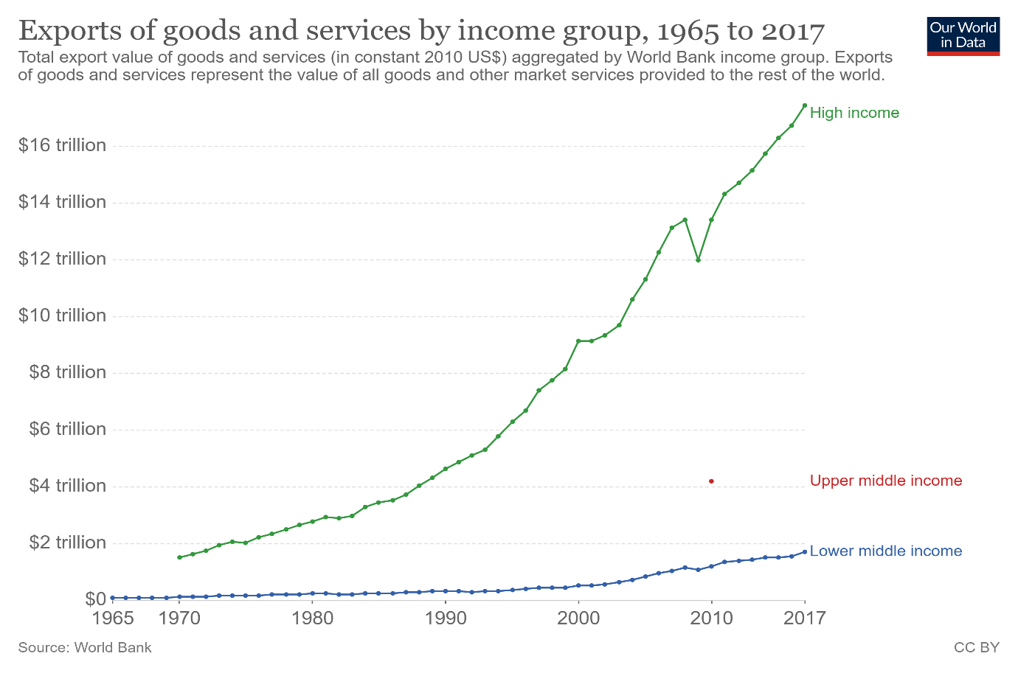

Target 17.12: Remove trade barriers for least-developed countries.

Tariffs for developing countries - Indicator 17.12.1 is the average tariffs faced by developing countries, least developed countries and small island developing States.

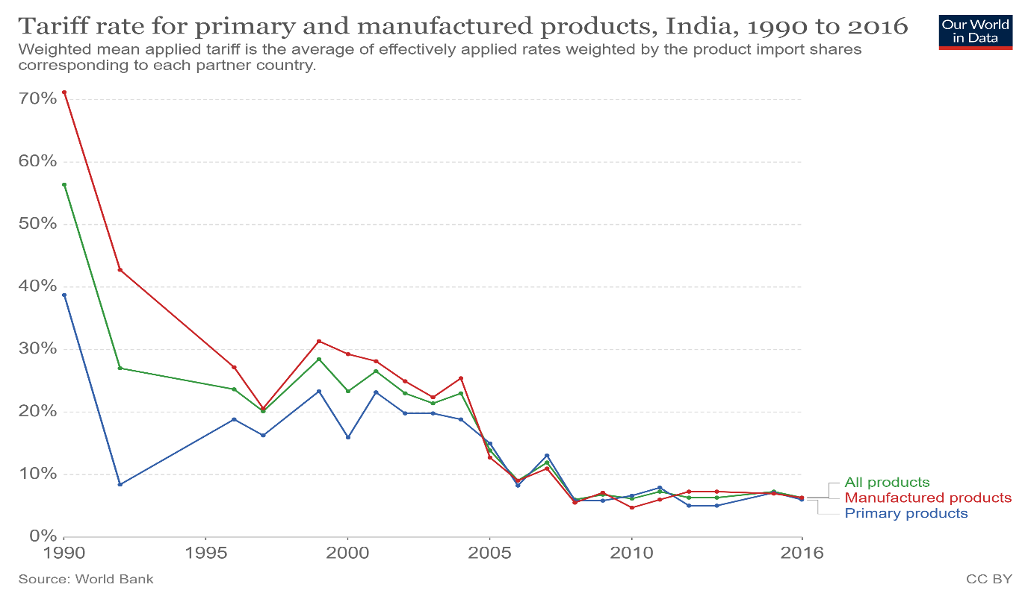

Target 17.13: Enhance global macroeconomic stability.

Macroeconomic Dashboard - Indicator 17.13.1 is the Macroeconomic Dashboard.

Target 17.14: Enhance policy coherence for sustainable development.

Policy for sustainable development - Indicator 17.14.1 is the number of countries with mechanisms in place to enhance policy coherence of sustainable development.

Target 17.15: Respect national leadership to implement policies for the sustainable development goals. Respect each country’s policy space and leadership to establish and implement policies for poverty eradication and sustainable development.

National results frameworks - Indicator 17.15.1 is the extent of use of country-owned results frameworks and planning tools by providers of development cooperation.

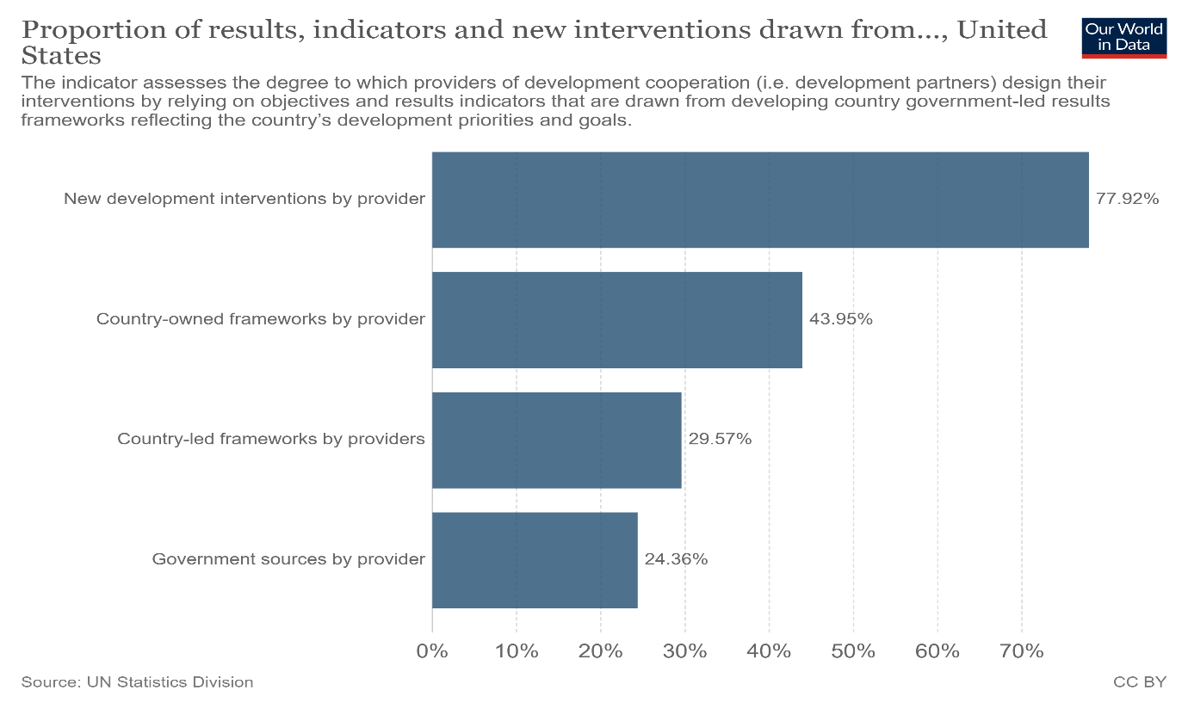

Target 17.16: Enhance the global partnership for sustainable development.

Progress in multi stakeholder development - Indicator 17.16.1 is the number of countries reporting progress in multi stakeholder development effectiveness monitoring frameworks.

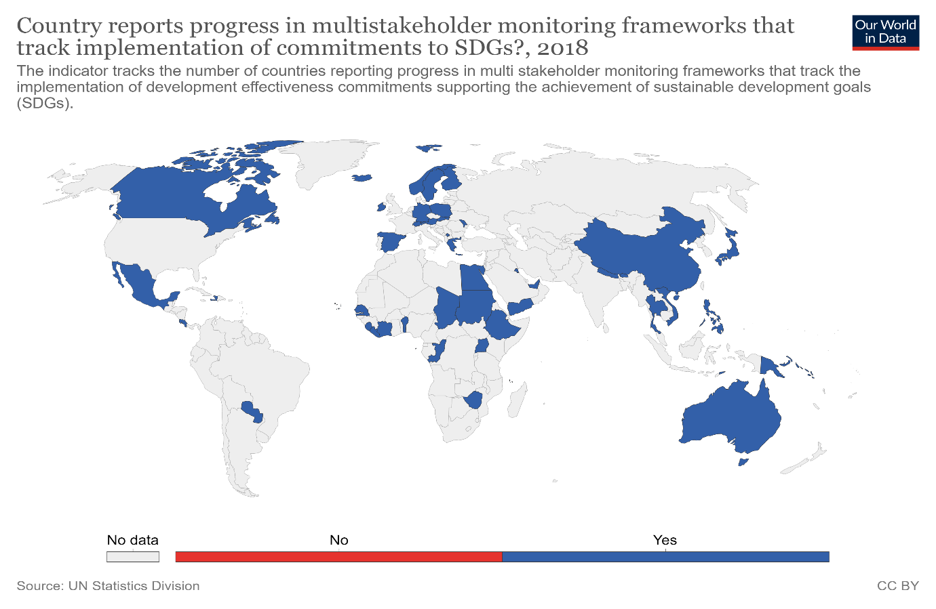

Target 17.17: Encourage effective partnerships.

Public, private and civil society partnerships - Indicator 17.17.1 is the amount of United States dollars committed to (a) public-private partnerships and (b) civil society partnerships.

Target 17.18: Enhance availability of reliable data.

Statistical Capacity - Indicator 17.18.1 is the proportion of sustainable development indicators produced at the national level with full disaggregation when relevant to the target, in accordance with the Fundamental Principles of Official Statistics.

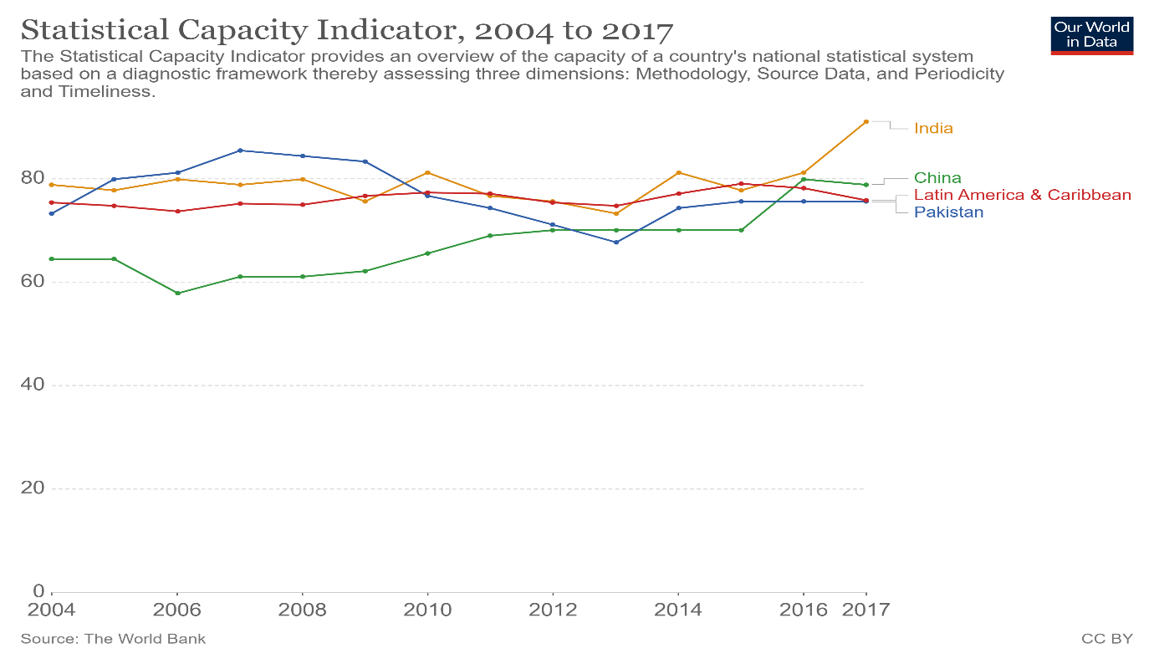

National statistical legislation - Indicator 17.18.2 is the number of countries that have national statistical legislation that complies with the Fundamental Principles of Official Statistics.

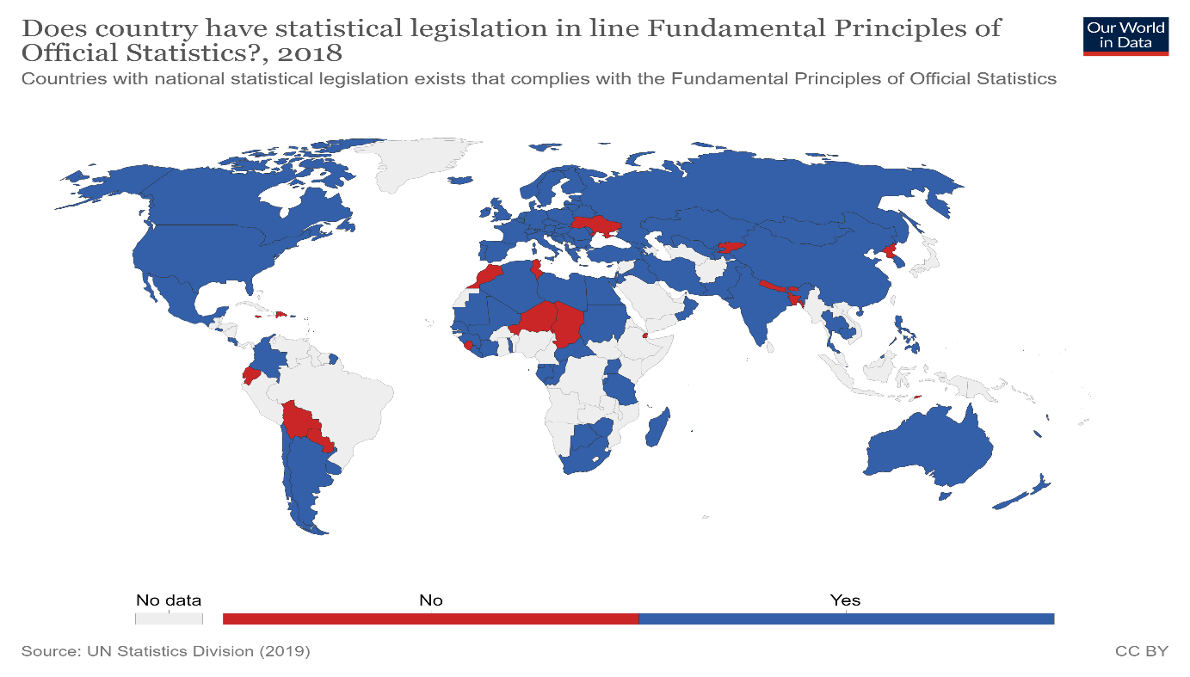

National statistical plans - Indicator 17.18.3 is the number of countries with a national statistical plan that is fully funded and under implementation.

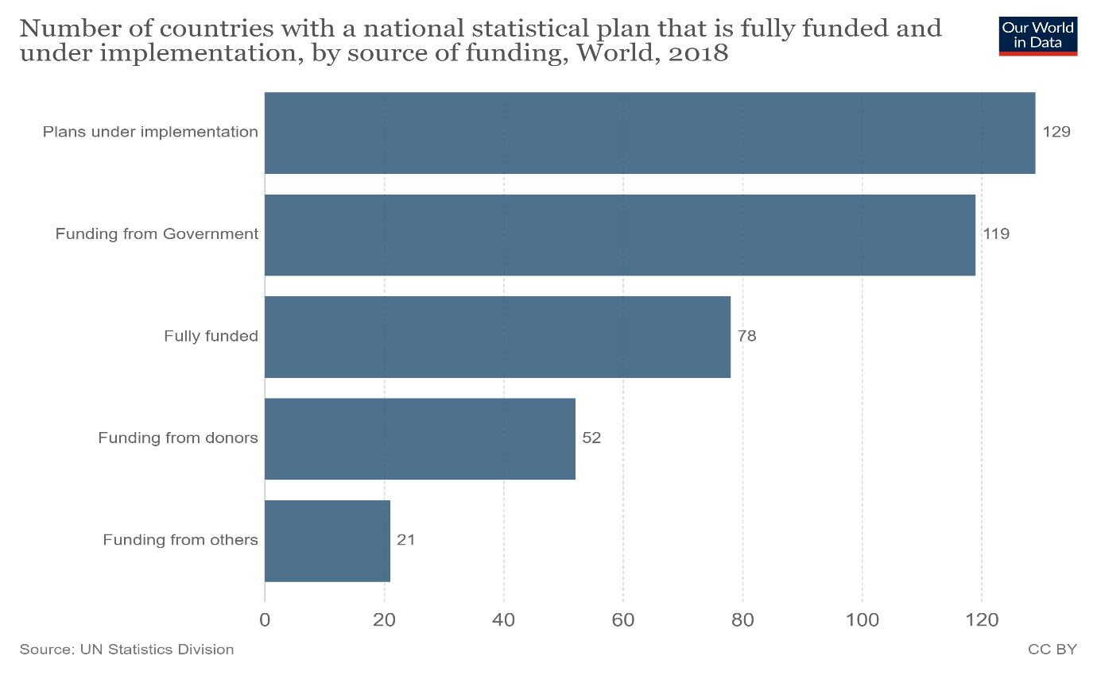

Target 17.19: Further develop measurements of progress.

Resources for statistical capacity - Indicator 17.19.1 is the dollar value of all resources made available to strengthen statistical capacity in developing countries.

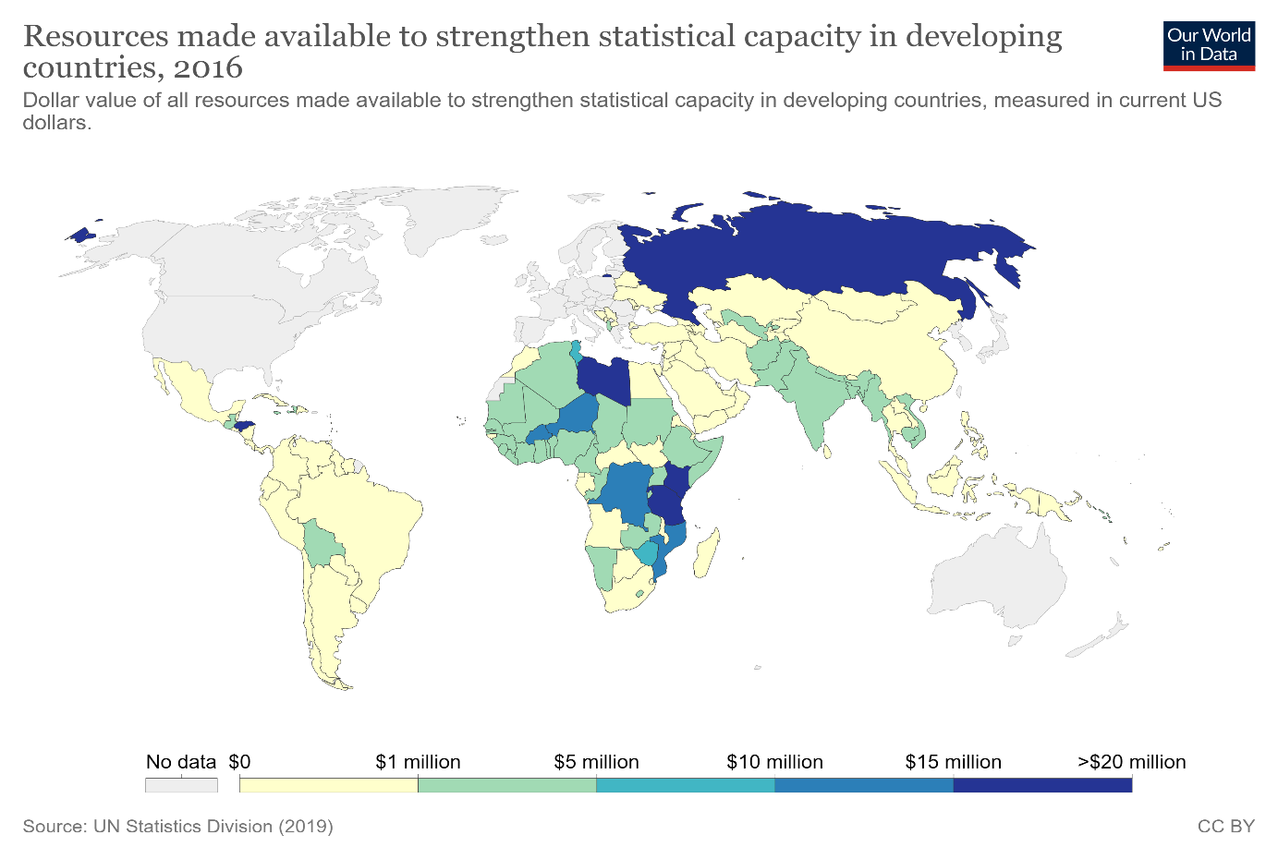

Completeness of census, birth and death registration - Indicator 17.19.2 is the proportion of countries that (a) have conducted at least one population and housing census in the last 10 years; and (b) have achieved 100 per cent birth registration and 80 per cent death registration.

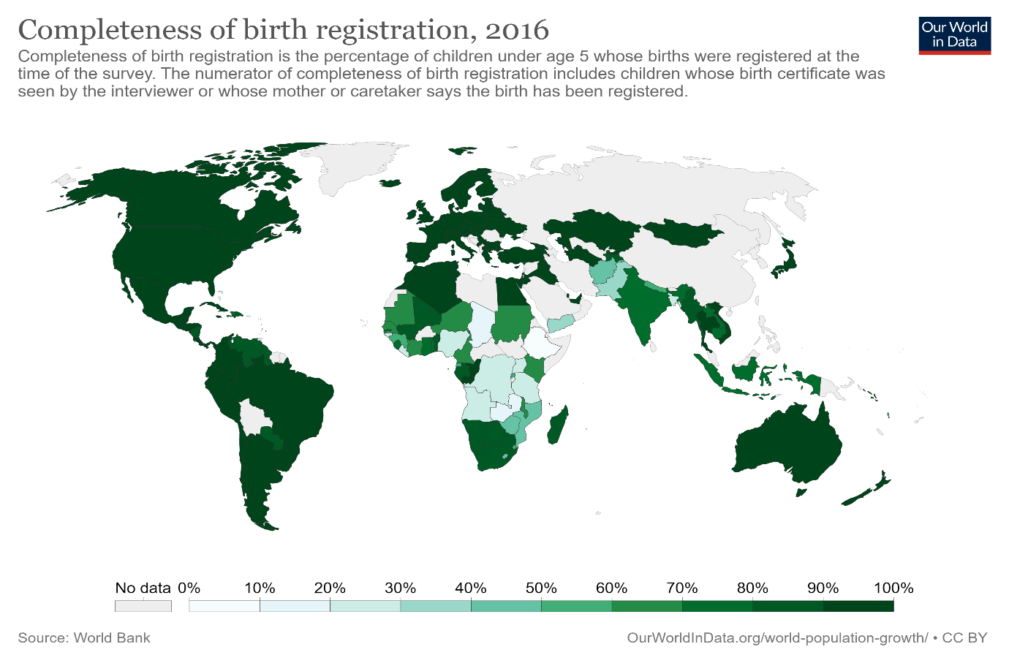

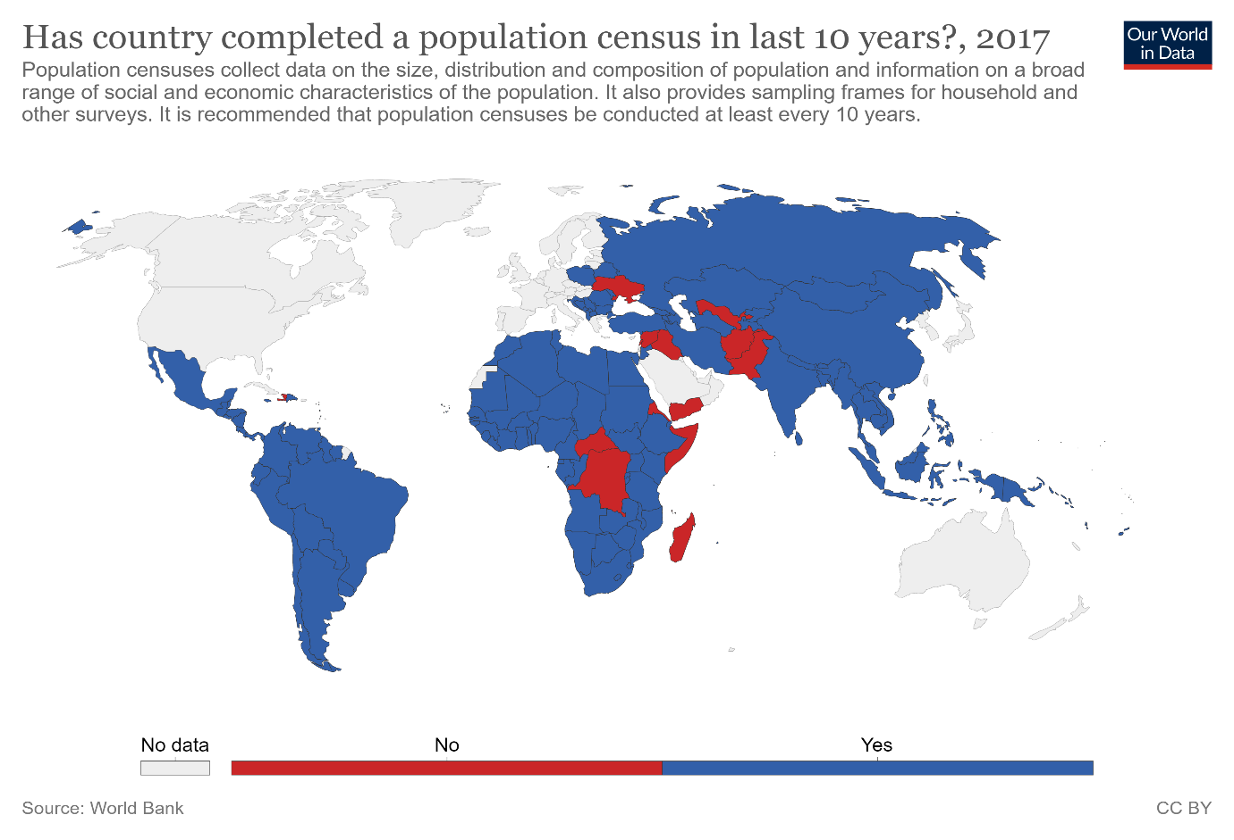

 This area examines India's requirements and gaps in the methods for usage of the goals, by expanding upon the conversation of every one of the other 16 goals.

1. **Promotion of online portals by the government** **:** The government should introduce and spread awareness about free and easily accessible portals that citizens can use to get immediate help, a forum to share grievances and contact other people in similar situations or have already faced problems for guidance and support.

ss